

**Full-Stack Web Development Roadmap for Beginners**

Following is the roadmap to learn **Full-Stack Web Development** skills for a total beginner (**no coding** or **computer science background** needed). It includes FREE learning resources for technical skills (or tool skills) + soft (or core) skills + Practice + Showcasing your work to get interview calls + Cracking Interview.

Total Duration : **6 Months**.

**2 hours** in Tools Skills + **0.5 hours** in Core fundamentals + **1.5 hours** in practice = **4 hours study Every Day**.

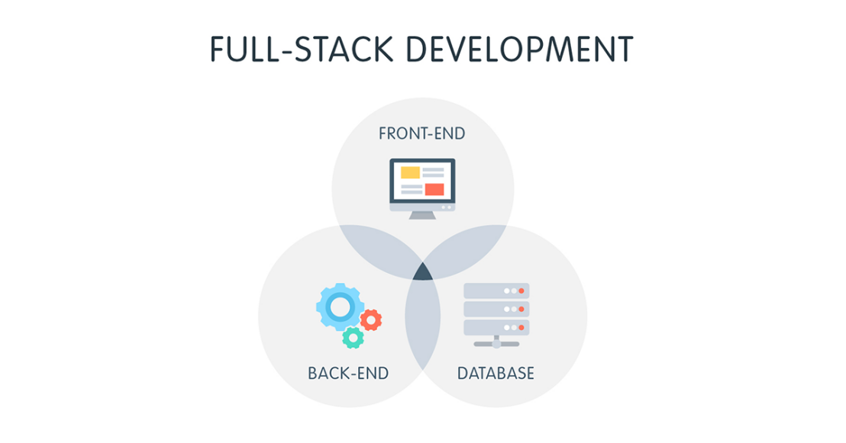

**Week 0: Do Proper Research and protect yourself from SCAMs.**

Unfortunately, a lot of systematic scams are happening in ed tech, especially in the Tech field where aspirants are provided with false promises like a 100% job guarantee or trapped into “Masterclasses” which are nothing but sales pitches to upsell their low-grade courses at exorbitant prices. You need to do complete research about the market and mentors before starting your journey. Providing you the links to a few posts that we have made in this regard which will support your research.

Even though these posts are **NOT** sufficient, do your additional research.

**Week 1 and 2: Foundations of Web Development + LinkedIn Profile**

* **HTML ( Structure web pages )**.
  + HTML stands for HyperText Markup Language. It is used on the frontend and gives the structure to the webpage which you can style using CSS and make interactive using JavaScript.
  + **Free Resources**
    - **<https://www.w3schools.com/html/html_intro.asp>**
    - **English -**[HTML Full Course for Beginners | Complete All-in-One Tutorial | 4 Hours](https://www.youtube.com/watch?v=mJgBOIoGihA&ab_channel=DaveGray)
    - **Hindi -**[HTML Tutorial for Beginners | Complete HTML with Notes & Code](https://www.youtube.com/watch?v=HcOc7P5BMi4&t=1s&ab_channel=ApnaCollege)
    - [HTML Full Course - Build a Website Tutorial](https://www.youtube.com/watch?v=pQN-pnXPaVg&ab_channel=freeCodeCamp.org)
* **CSS ( Style web pages )**
  + **CSS or Cascading Style Sheets** is the language used to style the frontend of any website. CSS is a cornerstone technology of the World Wide Web, alongside HTML and JavaScript.
  + **Free Resources**
    - Articles
      * <https://www.w3schools.com/css/>
      * [Web.dev by Google — Learn CSS](https://web.dev/learn/css/)
    - Videos
      * English - [HTML and CSS For Absolute Beginners | 2024 Crash Course](https://youtu.be/MBlkKE0GYGg?si=VoFxeH8qx1X0YU5a)
      * Hindi -[CSS Tutorial for Beginners | Complete CSS with Project, Notes & Code](https://youtu.be/ESnrn1kAD4E?si=4Z9yNQF0gmYpDEJn)
* **CheckPoint**
  + Now that you have learnt HTML and CSS, you should be able to build static web pages. I recommend you to build as many test projects.
  + **Project Ideas**
    - Try to copy the design of a website that you like.
      * Here is a [simple blog design in figma](https://www.figma.com/file/nh0V05z3NB87ue9v5PcO3R/writings.dev?type=design&node-id=0%3A1&t=2iQplaIojU3ydAfW-1) that you can try to copy.
      * Or try to rebuild the [webpages of this website](https://cs.fyi/).
    - Take some inspiration from [personal portfolios of others](https://astro.build/showcase/) and build your own personal portfolio
* **JavaScript ( Basics )** : Add functionality to web pages.
  + JavaScript allows you to add interactivity to your pages. Common examples that you may have seen on the websites are sliders, click interactions, popups and so on.
  + Free Resources:
    - Articles
      * <https://javascript.info/>
      * [Build 30 Javascript project in 30 days](https://javascript30.com/)
    - Videos
      * [JavaScript Crash Course For Beginners](https://www.youtube.com/watch?v=hdI2bqOjy3c&t=2s&ab_channel=TraversyMedia)
      * <https://youtube.com/playlist?list=PLGjplNEQ1it_oTvuLRNqXfz_v_0pq6unW&si=x-vmaXuKmTw9sZej>
* **LinkedIn - Core Skill**
  + Create a professional-looking LinkedIn profile.
  + Have a clear profile picture and banner image.
  + Add tags such as: Open to work etc.
  + Use this LinkedIn Checklist to create a profile: Click here.